# Silver In Agrochemicals Bactericides

Bactericide also known as “ germicides” is a substance that kills bacteria and are either disinfectants, antiseptics or antibiotics

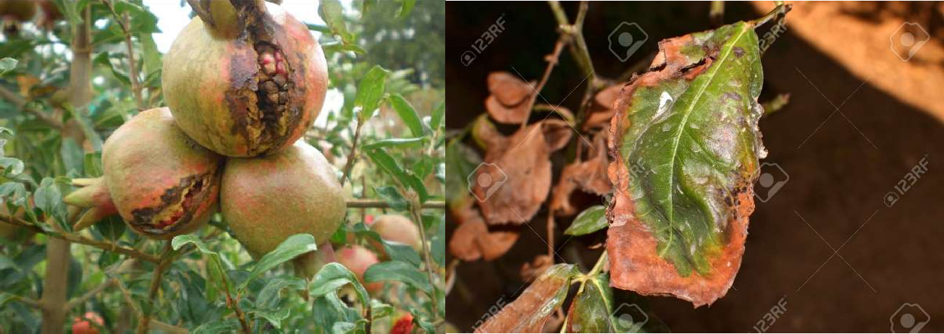

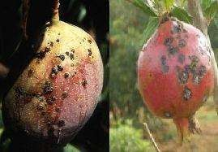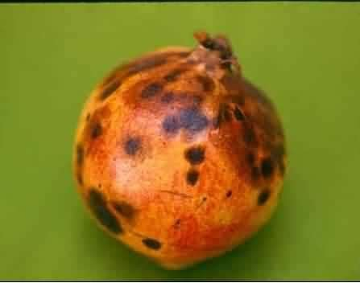

### Bactericides are used to Agricultural and food processing.

**Agricultural Bactericides**

Plant diseases caused by bacteria are very difficult to control, especially when a bacteria like CLas resides in the phloem of the plant vascular system, and few bactericides are available to treat bacterial diseases. Although Silver has been used in agriculture to protect plants from bacterial diseases, when used systemically at bactericidal levels.

**Common Bactericides in Agro;**

1. Based on **Micro Silver activated Hydrogen Peroxide**, which has a very broad- spectrum activity (Bacteria, Fungi, Viruses, Spores & Algae)

H2O2 IP grade - 50 % Nano silver IP grade - 500 ppm pH value - 1.5 – 2.0

Shelf life - 24 months

1. 2-Bromo 2- Nitro propane 1,3,diol
2. Validamycin, Streptomycin, Salmycin

# Food Industry

The food industry most often uses sanitizing procedures, so the information presented herein will focus on the more common products utilized. Regardless of the product, the sanitizing solution must be tested to verify that the desired concentration is consistently present. Too little sanitizer, of course, can result in unacceptable efficacy, while too much sanitizer can yield residues that do not meet standards.

## Common Bactericides in Food industries;

### Hypochlorites

Chlorine compounds are widely used in the food industry to kill bacteria and disinfect. Examples include treating pasteurizer cooling water, washing fruit and vegetables and disinfecting food contact surfaces.

Effectiveness, low cost and ease of manufacturing make hypochlorites the most widely used sanitizers. Sodium hypochlorite is the most common compound and is an ideal sanitizer, as it is a strong oxidizer.

### Disadvantages;

Hypochlorites cause broad microbial mortality by damaging the outer membrane, likely producing a loss of permeability control and eventual lysis of the cell. In addition, these compounds inhibit cellular enzymes and destroy DNA. Spores, however, are resistant to

hypochlorites, as the spore coat is not susceptible to oxidation except at high concentrations coupled with long contact times at elevated temperatures.

1. **Presence of organic material.** Organic material such as food residues decreases the effect of chlorine. For proper disinfection, use chlorine on cleaned surfaces only. Make sure you remove all organic material residue including fat and protein, before you apply chlorine as a sanitizer.
2. **The pH of a chlorine solution.** The level affects the antimicrobial activity. Use chlorine solutions with a pH range of 6.5 to 7.0 for optimum antimicrobial activity. At pH values near 4.0, hypochlorite solutions are most effective, but very unstable. At high pH values, the efficacy of chlorine is reduced. If you are using a highly alkaline cleaner to remove protein and fat residues, rinse the surfaces thoroughly before applying chlorine solution because high pH residues will reduce the chlorine activity.
3. **Temperature.** Generally, chlorine antimicrobial activity increases with warmer temperatures. However, at high temperatures, chlorine compounds may release chlorine gas which is toxic. The potential of corrosion also increases as temperatures go up.
4. **Concentration.** Higher concentration of chlorine increases the effectiveness of killing micro organisms. However, high concentrations of chlorine are not recommended because they can cause corrosion, explosions, and adversely affect the health of workers. A chlorine concentration of 50 to 200 parts per million (ppm) is recommended to disinfect food contact surfaces including utensils, equipment, and tables.

Other disadvantages of hypochlorites are corrosiveness to metals, health concerns related to skin irritation and mucous membrane damage and environmental contamination. The latter is of concern as chlorine can combine with organic substances to form toxic chlorinated compounds, such as trihalomethanes and dioxins.

Hypochlorite use may be further restricted in the future.

### – SLV mega SUPER 1000 /

Silver based antimicrobial especially for agricultural bactericides, is based on a quickly acting formula for killing bacteria without corrosion and damage mucous membrane. No toxic and environmental friendly.

* Accurate composition
* Prevents the diseases caused by bacteria
* Longer storage life
* Dosage Level ; 0.02 – 0.1 %